**Object Oriented UML Modeling for ATM Systems**

**Abstract**

The Object-Oriented Modeling assists the programmer to address the complexity of a problem domain by considering the problem not as a set of functions that can be performed but primarily as a set of related, interacting Objects. This article is based on the approach of Object Oriented modeling through Unified Modeling Language (UML) for an ATM system in banking sector. The main aim of this article is to provide a flexible and faithful environment for a customer, who wants to do online banking transactions. After successful authentication, the customer can withdraw the desire amount (within the prescribed limit) from the ATM machine or can transfer amount to other account. User can also change the pin code. The ATM has solved many problems and now customer can have money transaction 24/7. In this article UML Class, Interaction diagram, Activity diagram & Use Case diagram are also designed for the ATM System.

Key Words: UML dynamic modeling, UML static modeling, Use case modelling

**Introduction**

The Unified Modeling Language (UML) is a very dominant modeling graphical language for specifying, constructing and documenting the artifacts of software system. UML is simply another graphical representation of a common semantic model. UML provides a comprehensive notation for the full lifecycle of object-oriented development UML is a collection of best engineering practices that have successful in the modeling for a design of a huge and complex systems. Modeling is very important for readability and reuse of the systems.

**Features of ATM Systems**

The ATM will service one customer at a time. A customer will be required to insert an ATM card and enter a personal identification number (PIN) - both of which will be sent to the bank for validation as part of each transaction. The customer will then be able to perform one or more transactions.

**Object-Oriented Analysis**

Object-oriented analysis looks at the problem domain, with the aim of producing a conceptual model of the information that exists in the area being analyzed. Analysis models do not consider any implementation constraints or how the system is to be built. The identified objects reflect entities and operations that are associated with the problem to be solved.

**Diagram Showing a Use Case diagram in UML**

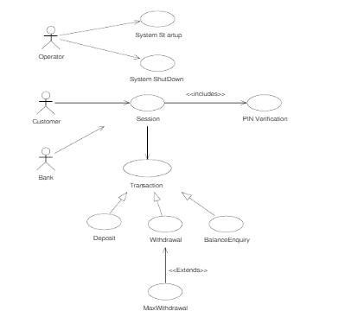

**THE DEPLOYMENT VIEW**

Example showing the deployment view of an atm :

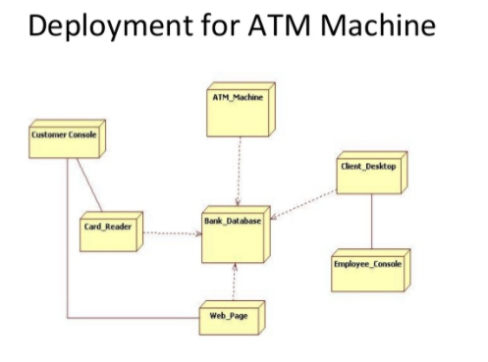

**The sequence diagram of an atm:**

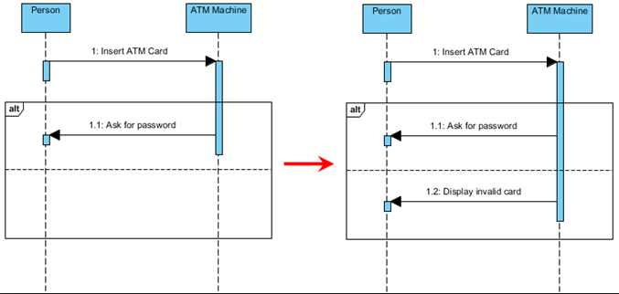

**Atm class diagram:**

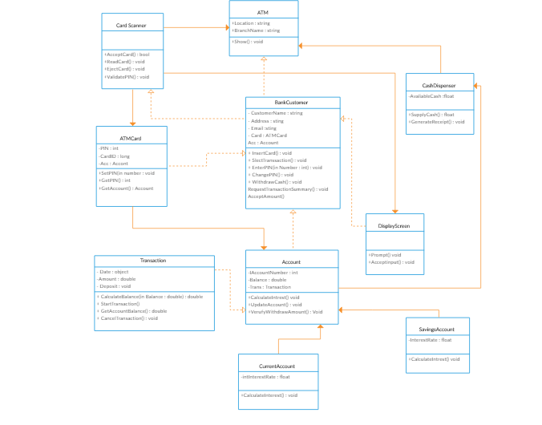

**Conclusion:**

As we are still working on this project , so far we know that OOAD is very important especially while you are designing an atm system and our team believes that the atm design is simple and is easy to use as a cardholder. As it provides you more than one option and allows you to create more than one accounts as desired.